**Parliamentary System and Secretariat Management training for secretariat staff of Province Assembly Members**

**Training Date:** 25 to 26 June 2023

**Training venue:** Hotel Eastern Star, Biratnagar

**Back Ground**

The Province Assembly Secretariat office requested to Office of the Chief Minister and Council Ministries, Koshi Province for capacity development training for Secretariat staff of Province Assembly Members. As per the request letter from the Secretariat office the OCMCM requested to Province Research and Training Academy. The Province Research and Training Academy planned to conduct the two slots of **Parliamentary System and Secretariat Management training** for Secretariat staff of Province Assembly members. The Province Assembly Secretariat office supported inviting and ensuring participation in the training.

Mr. Mahav Prasad Pokhrel, Executive Director/Secretary of OCMCM- chaired the opening ceremony. Dr. Dipak Kaphle, Principal Secretary- was invited as a chief guest in this program. The program formally opened by pouring water on the flower in the pot by the chief guest. Ms. Anita Guragain, LGE welcomed all participants and rap up her speech after being briefed objectives of the training.

**The Objective of the training:**

The participants will able to

* Explain the parliamentary system of Nepal
* Explain the role of Secretariat staff and the importance, Objectives, and effectiveness of the Secretariat office of Province Assembly Members.

**Output delivered:**

A total of 53 participants in Group A and 34 participants in Group B received the training. The training was very fruitful in as per the participant's opinion.

**Disaggregate data of participants:**

|  |  |  |  |  |  |  |  |  |  |  |
| --- | --- | --- | --- | --- | --- | --- | --- | --- | --- | --- |
| **S.N.** | **Gender** | | **Total** | **Ethnicity** | | | | | | **Remarks** |
| Women | Men | Dalit | Janajati | Madhesi | Muslim | BC | Other |
| 1 | 4 | 49 | 53 | 1 | 18 | 4 | 1 | 29 | 0 | Group A |
| 2 | 5 | 28 | 33 | 4 | 11 | 4 | 0 | 14 | 0 | Group B |

**Testimonial:**

**"** It was a very important program that supported enhancing the capacity of the secretariat. I would like to thank Province Assembly Secretariat and Province Research and Training Academy for this program. I think the training was not enough for us to gain all the thematic lines even though it will energize us to search for the required materials and learn more and more. The training was more effective if the Province Research and Training Academy provide us with travel costs from District to Biratnagar." (**Tej Prakash Sapkota_ participants, Secretariat of Province Assembly Members.)**

" I can't say that we can give 100 marks for this training but it was excellent training for you all to enhance your capacity. Hence, the training supported you to build networking of the Secretariat staff of Koshi Province. We will be developed the training need assessment format and will collect the training needs of all Secretariat staff of Koshi Province. After demand collection, the Province Research and Training Academy will provide you the capacity development training as per needed." **(Gopal Prasad Parajuli, Province Assembly Secretary)**

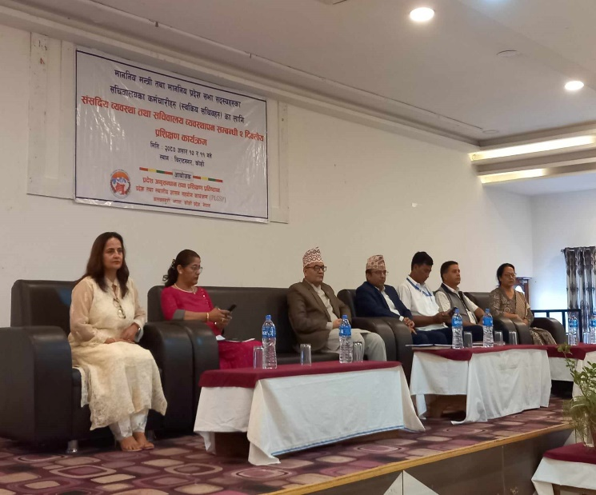**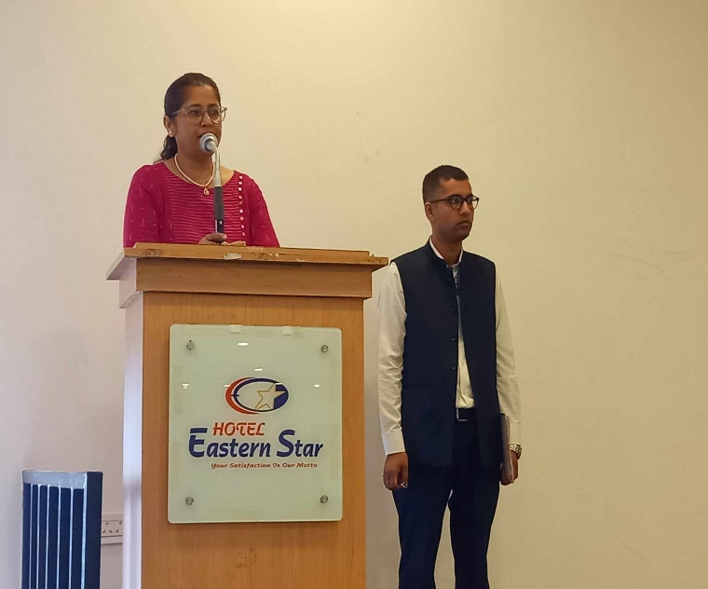Photos:**

