Training of Trainers (ToT) to staff of the Province Ministries and subordinated office

Training Date: 18-22 March, 2024
Training venue: Training hall of Province Research and Training Academy, Kalwalguri, Jhapa
Back Ground
Officers of the Province Ministries and subordinated offices should have to facilitate the training as required. Likewise, the Province Ministries have their annual plan and programs which they have to organize and facilitate in various thematic areas. In this condition, the officer must have knowledge and skills regarding the training facilitation. As per the needs and demand of the Province Ministries the Province Research and Training Academy put one event of ToT in ASIP for this fiscal year.
On the other hand, the Province Research and Training Academy has been conducting service entry and in-service training for the gazette and non-gazette staff of Provincial and Local Governance where it has been mobilizing government officers as a resource person. In this context, the government officer has to prepare as a facilitator by gaining training facilitation skills and knowledge. As a result, the Province Research and Training Academy is going to conduct the Training of Trainers (ToT) to produce the trainers in the Province Ministries.
The Province Research and Training Academy conducted the ToT by making a bilateral agreement with the Nepal Administrative Staff College for the whole package of Training of Trainers (ToT). Consequently, the staff college managed and facilitated the ToT in Kalwalguri, Jhapa.

The Objective of the training:
The participants will able to:
- Explain the various methods of training facilitation,
- Explain Adult learning principles and styles,
- Set training objectives,
- Do Training Need Assessment (TNA),
- Adopt the training facilitation skill.

Output delivered:
A total of 19 participants received the five-day ToT training. The participants were satisfied and very grateful to have such valuable training.
Disaggregate data of participants:
S.N. | Gender |  | Total | Ethnicity |  |  |  |  |  | Remarks
 | Female | Male |  | Dalit | Janajati | Madhesi | Muslim | BC | Other
1 | 4 | 15 |  | 0 | 3 | 1 | 0 | 15 | 0

Testimonial:
" The training was very fruitful to us even though there was a little bit of confusion before the training that what is the subject matter and resource person while ensuring the participation in this training. He emphasized that TNA, Adult learning, training methodologies, Objective setting, Session plan preparation, connecting to participants, Facilitation and Presentation skills, Training Management and Coordination, and Practical sessions (presentation by all individual participants) were the major learning of the ToT. He highlighted that we have gained very much training facilitation knowledge and skills if we compared our knowledge before and after this training. Lastly, he again appreciated the Province Research and Training Academy for an important program." (Dambar Prasad Ghimire_ participant, Ministry of Economic Affairs and Plan)
" The ToT certificate will become more effective when after you implement the knowledge and skills that you received during the five days of training. I think you all are lucky to have had the opportunity to receive training from a huge team of Staff College. The Province Research and Training Academy just starting to manage training including its hostel so we have to improve the overall management of the events. Hence, we are expecting your valuable feedback and suggestions. He wished to all participants for a successful tenure in the training sector." (Bishnu Kumar Karki_ Executive Director_ Province Research and Training Academy)
"Today's presentation proved your ability in the training sector. He congratulated all participants for their hard work to make the presentation effective. He highlighted that we are very thankful to the Province Research and Training Academy for the opportunity to facilitate the ToT. The training closing session is the starting period for the training because the journey will start after accomplishing the training. He said that you can effectively implement the skills and knowledge that you have gained through the training. He added that in this journey the staff college just played the vital role of motivator you all." (Binod Kumar Bista, Senior Director of Studies_ Nepal Administrative Staff College)

Photos:

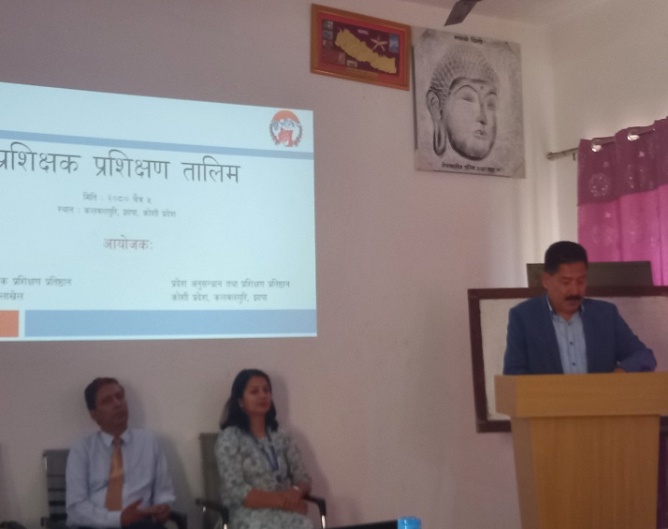 | 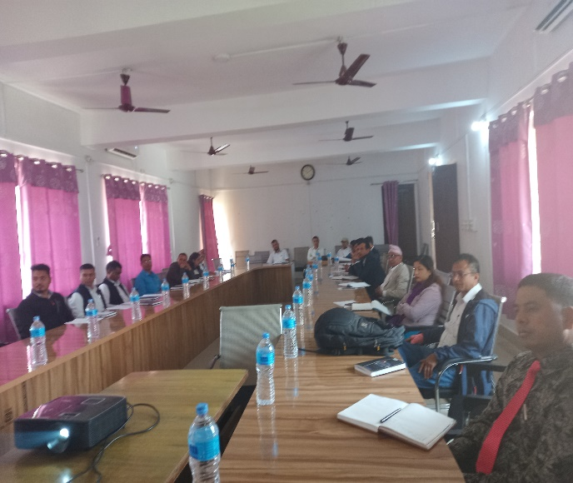
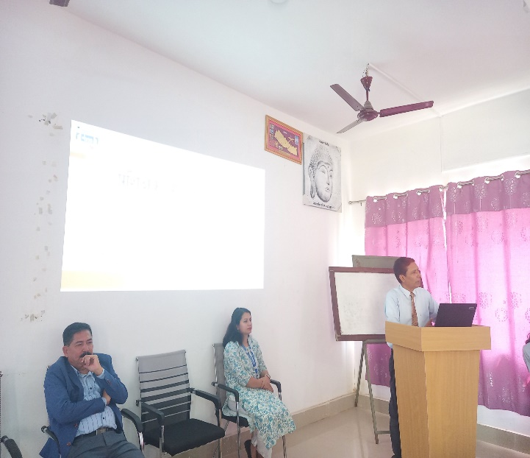 | 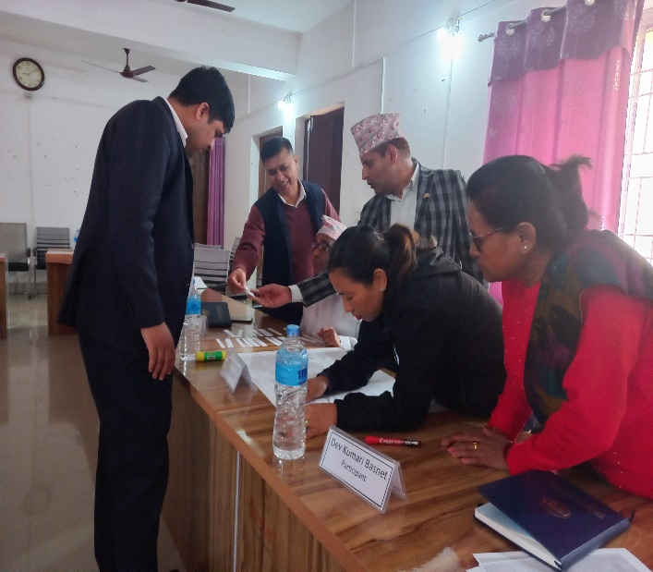
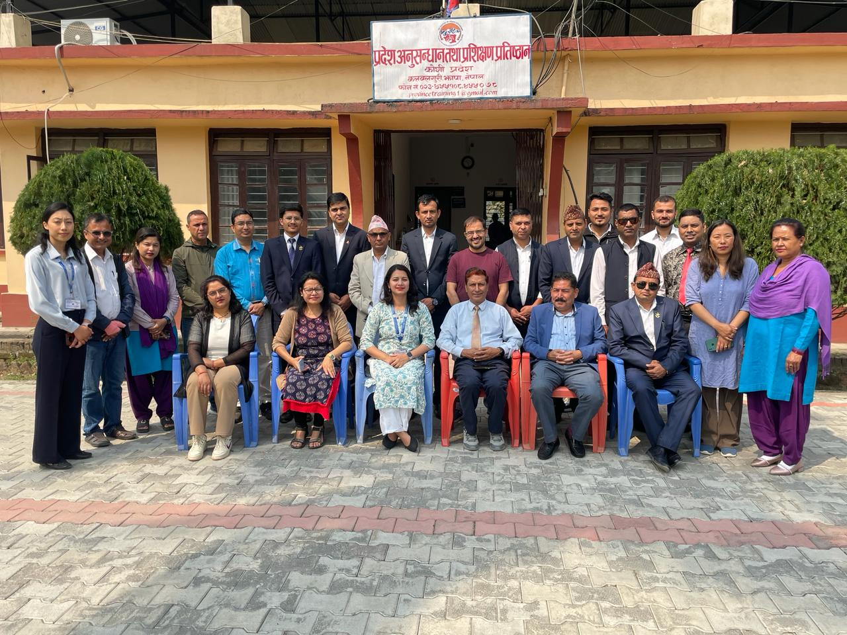 | 